LAB Logbook
Lab 7
#Graphs for Accuracy and Loss Function for VGG16 and VGG19 (4 graphs in total)
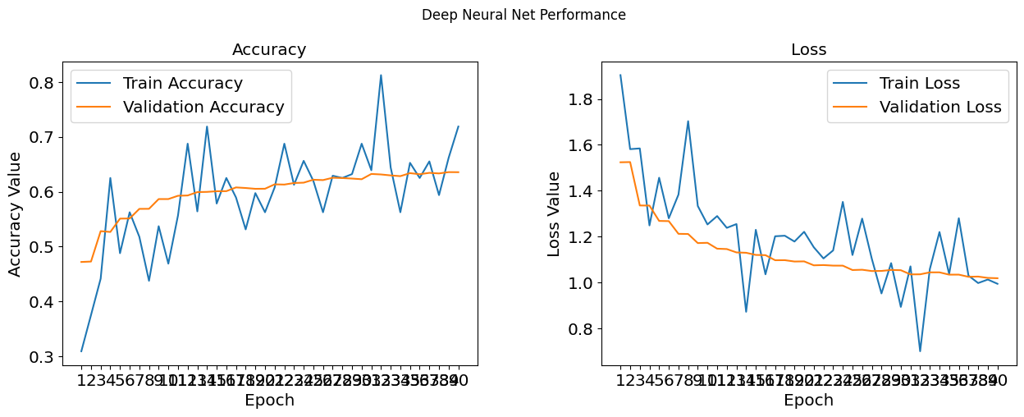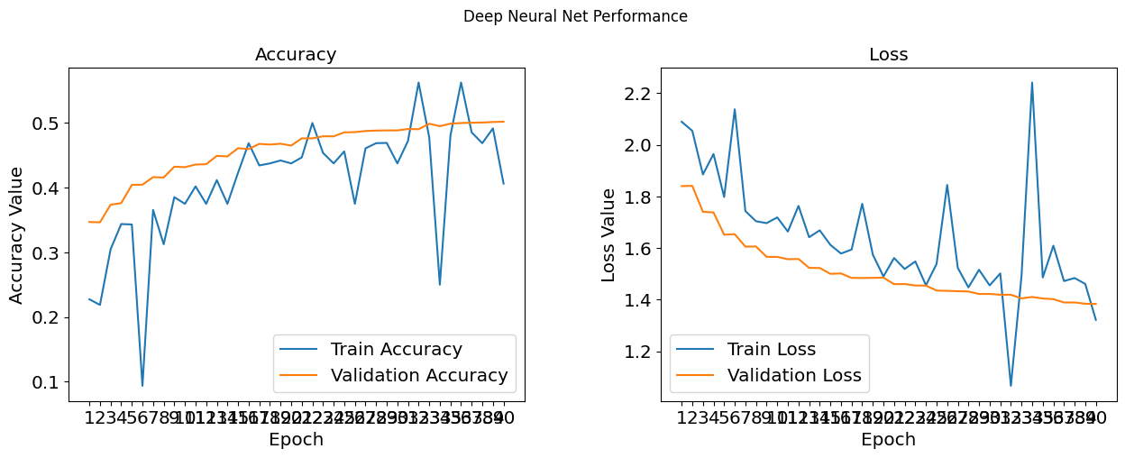
#The optimal number of epochs for training your VGG16 model
Ans:25
Copy your early-stop code
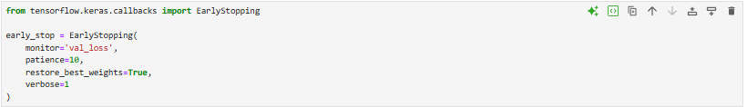
#The final Performance Table
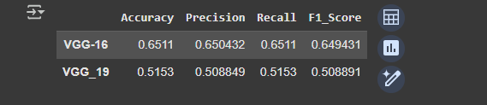
#The performance comparing histogram of VGG16 and VGG19
